**1. Solar Power System**

**1.1 Introduction**

A basic solar power system consists of four parts: solar panel, regulator, battery and inverter. The solar panel converts sunlight into DC electricity to charge the battery. This DC electricity is fed to the battery via a solar regulator which ensures the battery is charged properly and not damaged. DC appliances can be powered directly from the battery, but AC appliances require an inverter to convert the DC electricity into 240 Volt AC power. Some DC appliances can be connected to the regulator to take advantage of the Low Voltage Disconnect and protect the battery. [1]

**1.2 Diagram/Schematic**

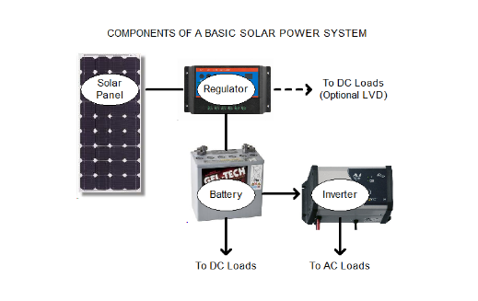

*Diagram 1- A basic solar power system diagram*

**1.3 Components description**

**1.3.1 Solar panel**

Solar panels are classified according to their rated power output in Watts. This rating is the amount of power the solar panel would be expected to produce in 1 peak sun hour.

Solar panels can be wired in series or in parallel to increase voltage or current respectively. The rated terminal voltage of a 12 Volt solar panel is usually around 17.0 Volts, but through the use of a regulator, this voltage is reduced to around 13 to 15 Volts as required for battery charging.

Solar panel output is affected by the cell operating temperature. Panels are rated at a nominal temperature of 25 degrees Celsius. The output of a typical solar panel can be expected to vary by 2.5% for every 5 degrees variation in temperature. As the temperature increases, the output decreases. In many cases, the temperature of solar panel could be 30 degree Celsius higher than the ambient temperature, thus cooling and ventilation systems should be well designed in order to get optimal power output.

**1.3.2 Solar Regulator**

The purpose of solar regulators is to regulate the current from the solar panels to prevent the batteries from overcharging. A solar regulator is used to sense when the batteries are fully charged and to stop, or decrease, the amount of current flowing to the battery.

Most solar regulators also include a Low Voltage Disconnect feature, which will switch off the supply to the load if the battery voltage falls below the cut-off voltage. This prevents the battery from permanent damage and reduced life expectancy.

A solar regulator also prevents the battery from back feeding into the solar panel at night and, hence, flattening the battery. Solar regulators are rated by the amount of current they can receive from the solar panels.

**1.3.3 Inverter**

An inverter is a device which converts the DC power in a battery to 240V AC electricity. Inverters come in two basic output designs, pure sine wave and modified sine wave (square wave).

Pure sine wave inverters provide AC power that is virtually identical to, and often cleaner than, power from the grid. Inverters are generally rated by the amount of AC power they can supply continuously. Manufacturers generally also provide 5 second and 1/2 hour surge figures. The surge figures give an idea of how much power can be supplied by the inverter for 5 seconds and 1/2 an hour before the inverter's overload protection trips and cuts the power.

**1.3.4 Battery**

Deep cycle batteries that are used in solar power systems are designed to be discharged over a long period of time (e.g. 100 hours) and recharged hundreds or thousands of times, unlike conventional car batteries which are designed to provide a large amount of current for a short amount of time. To ensure long battery life, batteries should not be discharged beyond 70% of their capacity, i.e. 30 % capacity remaining.

**1.4 Temperature condition in Newman**

The average temperature in Newman could vary between 9.3 degrees Celsius and 39.7 degrees Celsius in one year [2].

**2. Wind Power System**

**2.1 Introduction**

Wind power is the use of air flow through wind turbines to mechanically power generators for electric power. Wind power, as an alternative to burning fossil fuels, is plentiful, renewable, widely distributed, clean, produces no greenhouse gas emissions during operation, consumes no water, and uses little land. The net effects on the environment are far less problematic than those of non-renewable power sources. [3]

**2.2 Principle of operation**

A wind turbine works on a simple principle. The rotor is connected to the main shaft, which spins a generator to create electricity. Wind turbines are mounted on a tower to capture the most energy. At 30 meters or more above ground, they can take advantage of faster and less turbulent wind. Wind turbines can be used to produce electricity for a single home or building, or they can be connected to an electricity grid for more widespread electricity distribution. [4]

**2.3 Characteristic of wind power**

**2.3.1 Relationship between wind power output and wind speed**

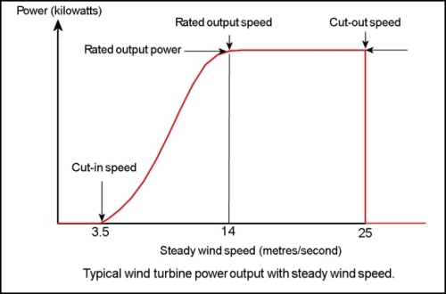

This figure shows that three stages in wind power system, thus the desire wing speed is between 14 m/s and 25 m/s.

**2.3.1 Theoretical power output**

The available power can be calculated by following equation:

$P_{theoretical}=\frac{1}{2}ρU^{3}\frac{πd^{2}}{4}$,

Where U is the wind speed in meters per second, $ρ$ is the air density in kilograms per cubic meters, d is the rotor diameter in meters and P is the output power in watts.

**2.3.2 The Betz limit**

There is a theoretical limit on the amount of power that can be extracted by a wind turbine from an airstream. It is called the Betz limit which is around 59% [5]. Calculated as following:

$μ=\frac{P_{actual}}{P_{theoretical}}$

**2.4 Wind information in Newman**

According to the Newman weather website, the average wind speed in Newman is around 13.2 km/h (3.67 m/s) in a whole year [6], which is not suitable for using wind turbines.

**3. Diesel generator**

**3.1 Introduction**

A diesel generator is the combination of a diesel engine with an electric generator (often an alternator) to generate electrical energy. This is a specific case of engine-generator. A diesel compression-ignition engine often is designed to run on fuel oil, but some types are adapted for other liquid fuels or natural gas. [7]

**3.2 Principle of operation**

There are two components working together, one is engine and the other one is electromagnetic generator. Diesel engine burns diesel fuel in order to produce motion for the generator, which converts the motion into electricity by using electromagnets.

The two components are connected by a crankshaft. The crankshaft transfers the motion produced by the diesel engine to the magnets of the generator assembly.

The fuel tank of the diesel engine is filled and the engine is started. The governor is used to standardize the power output of an engine, so this in turn then standardises the power output of the generator.

Once the diesel engine starts and turns the crankshaft that connects to the generator, the central axle of the generator is spun within a chamber containing electromagnets. This high-speed motion causes an electric current to be produced. [8]

Reference:

1. <https://www.solaronline.com.au/solar_system_basics.html>
2. <http://www.bom.gov.au/climate/dwo/IDCJDW6096.latest.shtml>
3. <https://en.wikipedia.org/wiki/Wind_power>
4. <https://energy.gov/eere/wind/animation-how-wind-turbine-works>
5. <http://www.wind-power-program.com/turbine_characteristics.htm>
6. <http://wind.willyweather.com.au/wa/pilbara/newman-airport.html>
7. <https://en.wikipedia.org/wiki/Diesel_generator>